**Expanded Abstract for the United States Society on Dams 2025 Annual Conference**

**Title:** *Enhancing Watershed Regional Resilience through Collaborative Holistic Risk Management*

**Authors:** Frank Randon, Homeland Security, US Army Corps of Engineers

Ed Hecker, Director of Operations, National Hazard Mitigation Association

Preston Wilson, President, Resilience Solutions Consulting

Paula Scalingi, Ph.D., Executive Director, Institute for Innovating Security and Resilience and Chair, Regional Collaborative Coordinating Council

_____________________________________________________

Major flood events of increasing occurrence, scope, scale, and costs underscore the compelling need to address rapidly escalating risks from climate change and other threats and hazards affecting dams, levees, other water management systems, and interdependent critical infrastructures within watersheds and the communities they support. In the past year alone there have been several such events including Hurricane Helene in September 2024, which wreaked a swath of destruction from Florida’s Big Bend region through several U.S. southeast states, and Hurricane Milton two weeks later causing extensive flooding across central Florida. Catastrophic flooding earlier in 2024 caused dam-related incidents in Minnesota, Michigan and Wisconsin.

**Infrastructure Dependencies and Interdependencies—Determinants of Watershed Resilience**

The U.S. Geological Survey describes a watershed as “an area of land that drains all the streams and rainfall to a common outlet, such as the outflow of a reservoir, mouth of a bay, or any point along a stream channel.” A watershed region can be a small local area or span several states and cross national borders. Each is unique because of location, types of weather, the number of people living there, way of life, and local and state rules and regulations.

The resilience of watershed regions relies on the secure and reliable functions and services of water management and other physical and cyber infrastructures and their supply chains. They include: water and wastewater, energy (electric power, oil, natural gas, hydropower, and other fuels—production and distribution); all modes of transportation—road, rail, shipping, including on inland waterways; healthcare, emergency services, and public safety; commercial businesses, community institutions, and national defense installations, as well as the “smart” information technologies and the human workforce to operate and manage them.

The operation of the physical structures, components, and electronic and cyber systems of these critical infrastructures are dependent on the functions and services of other infrastructures, which in turn are dependent on others. This creates complex multi-level layers of interdependencies that can cause simultaneous, escalating, and cascading impacts and/or damage throughout and beyond a watershed region resulting in prolonged disruptions of essential functions and services, impeding response actions, and complicating and delaying recovery and restoration of facilities, assets, and systems. The growing incorporation of smart technologies into systems and networks to improve management of an increasing range of functions and services adds additional layers ofinterconnectivity that can contribute to the severity of impacts**.**

**What Watershed Regional Resilience Requires**

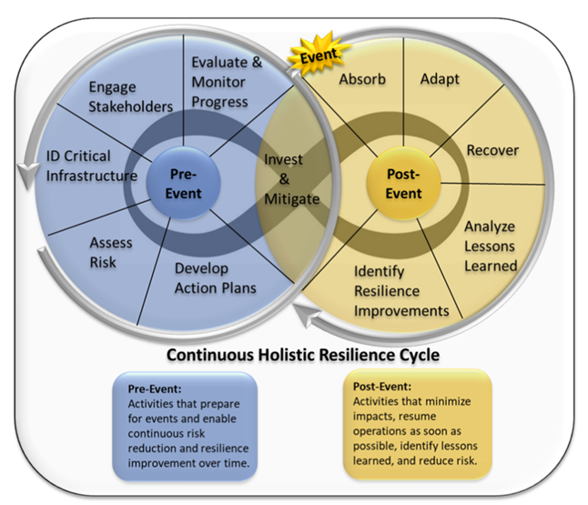Interdependencies-associated impacts from major flood events demonstrate the need for a *regional Holistic Life-cycle Approach* to assess watershed-related risks and develop and implement prioritized risk reduction actions. This Holistic Approach entails assessing regional risk and resilience needs and capabilities across the disaster management mission-space of preparedness, pre-event mitigation, response, recovery/restoration, and post-event mitigation, and includes protection and prevention. For watershed regional resilience, all these mission areas come into play, as this graphic demonstrates.

The Holistic Approach requires an understanding of the ongoing relationship between pre-and post-event resilience activities and the need for continuity and enhanced coordination among pre-and post-event mitigation, preparedness, recovery, and other risk reduction planning and actions, as well as investments to help assure the integrity of interdependent watershed management and other critical infrastructures that support the watershed and communities within it. This necessitates collaboration among local, state, and federal agencies, water management and critical infrastructures, and other key public-private sector organizations and institutions.

**Operationalizing the Holistic Approach**

The approach and process to undertake it have been developed and incorporated into an initial ***Nationwide*** ***Watershed Regional Risk and Resilience Goal & Strategy*** by a national Task Group of government and cross-sector experts as part of the USACE Dam Sector Regional Risk and Resilience Program (DSR3P). The Goal & Strategy and an accompanying Playbook of existing and new resources provide dam owners and operators and regional stakeholders with a customizable processes and tools to undertake regional risk and resilience assessments. The intent is to enable organizations and communities that have different levels of resilience-related knowledge, capabilities, staff, and financial resources to undertake a practical and achievable process to incrementally improve watershed resilience over time.

The Watershed Regional Risk and Resilience Goal & Strategy:

* Explains why watershed regional resilience is essential in an era of rapidly escalating risks from climate, technological, and other existing, emerging, and unanticipated threats and hazards, and the implications of infrastructure interdependencies within watersheds that drive and determine vulnerabilities, impacts, risk, and risk reduction priorities.
* Goes into detail on what watershed regional resilience is and requires, and provides 15 basic principles underlying resilient watershed regions.
* Identifies the comprehensive set of resilience Focus Areas that provides the basis of a regional risk assessment, the key needs and solutions within each of these Focus Areas, and the Attributes and Enabling Capabilities that must be considered to identify mitigation and other risk reduction actions.
* Describes in detail the essential multi-step Holistic Approach with guidance on how to operationalize each of the seven steps. The steps cover laying the foundation with stakeholder engagement, characterizing regional infrastructures and designing the assessment, data collection, undertaking the risk assessment, Action Strategy and Implementation Plan development, identifying and securing resources and investment for implementation and sustainment, and enabling continuous resilience improvement using lessons learned from future events, exercises, and best practices from other watershed regions.
* Provides guidance for low-resource communities and smaller infrastructures and organizations in undertaking the multi-set process.
* Addresses challenges regional decision-makers and key stakeholders typically face and how to address them, including how to access available resilience tools and resources, facilitate information-sharing, obtain necessary data, secure funding and other investments for implementation and sustainment, and generate political will and societal support.
* Provides examples of Watershed Regional Resilience Initiatives that have used a multi-step process.
* Explains how to help ensure necessary collaboration from the local to national levels to address policy obstacles and help develop and enhance information-sharing capabilities to enable risk assessments, improve preparedness and mitigation planning, and informed decision-making for response and recovery.
* Recommends ways for filling the gaps in watershed regional resilience enabling capabilities.
* Points out how watershed communities and their supporting infrastrucures can incorporate resilience into their region’s cultures.

The Goal & Strategy lastly highlights the benefits of Watershed Risk and Resilience initiatives for dam and water management systems owners and operators, regional cross-sector stakeholders, and local, state and federal agencies.

For watershed regional stakeholders these include:

* Providing the means to understand the changing threat environment, identify existing and potential vulnerabilities and impacts, and appreciate escalating all-hazards risks to interdependent infrastructures and communities.
* Bringing together private-public sector and non-profit organizations in collaboration to bridge organizational, bureaucratic, and institutional silos, and build the trust and relationships necessary to assess risk and agree on mitigation and other risk reduction measures to improve preparedness, response, and recovery.
* Enabling practitioners and experts to work with federal and state government partners and have access to guidance, technical assistance, avenues to share relevant information, and other tools and resources needed to characterize regional infrastructures, understand impacts and cascading disruptions associated with interdependent physical and cyber systems, and determine how to best invest in infrastructure upgrades to assure security and resilience.

For states the value of these initiatives, beyond improving regional watershed resilience, is in greatly increasing their engagement and information-sharing with key infrastructures and other organizations to provide improved mapping of statewide critical assets and chokepoints, including supply chains.

Federal agencies can use these regional initiatives to engage and build relationships with watershed regional stakeholders and have a direct way to learn about regional watershed resilience needs and provide federal tools and resources. These initiatives can also help in developing a shared understanding of regional critical assets and functions and how these can affect security and resilience at the national level.

**Ensuring the Nationwide Watershed Regional Risk and Resilience Goal & Strategy is Usable and Used**

The initial Goal & Strategy has recently been completed after validation by the Task Group and external review by additional cross-sector experts. The process to operationalize the Holistic Approach and the accompanying Playbook of tools and resources will be evaluated in 2025 in two pilot projects in different regions of the nation. Outcomes from the pilots and other information will be incorporated into version 2.0 of the Goal & Strategy. Ancillary activities include development of a promotional plan to encourage decisionmakers and key stakeholders in interested watershed regions around the country to adopt and customize the process, tools and resources for assessing risk and improving the resilience of their watershed regions.

In the longer term, with development of enhanced analytical capabilities and other enabling tools and resources, regional risk and resilience initiatives can be of significant utility in greatly improving understanding of priority all-hazard risks and targeting investments to strengthen the resilience of critical infrastructures and communities located within the nation’s watersheds.